Evaluating Warehouse Closure Feasibility Through Inventory Optimization at Mint Classics
Michele McCluskey
January 2026
Introduction
Mint Classics is a company which focuses on selling collectible model car products. The organization needs to determine if it can close one of its four warehouses without negatively affecting customer satisfaction. The research intends to discover inventory patterns together with performance measures which organizations can use to develop methods for process unification through stock rearrangement and inventory reduction without losing service quality.

The Data
The analysis used data from Coursera which provided nine connected CSV tables that contained information about warehouses and products and orders and their corresponding details. The data tables were brought into MySQL Workbench for both inspection and data evaluation purposes. The data covers the period from January 6, 2003, to May 31, 2005. For this project, the main emphasis was placed on the warehouse, products, orders, and order details tables.

Methodology
The first step of the audit process involved checking the number of records and their data types to determine if the information was accurate. Each table was checked for duplicate entries and missing values. The team checked all data types which required modifications to execute proper calculations without losing the exactness of information in the table.

Analysis and Findings
The analysis shows that the Classic Cars product line generates the highest profits, but also includes 7 of the 20 least profitable products. The category contains the largest amount of inventory stock. In contrast, lower-profit products tend to have smaller stock levels, suggesting that stock levels generally correspond to profitability (See figures 1-4).

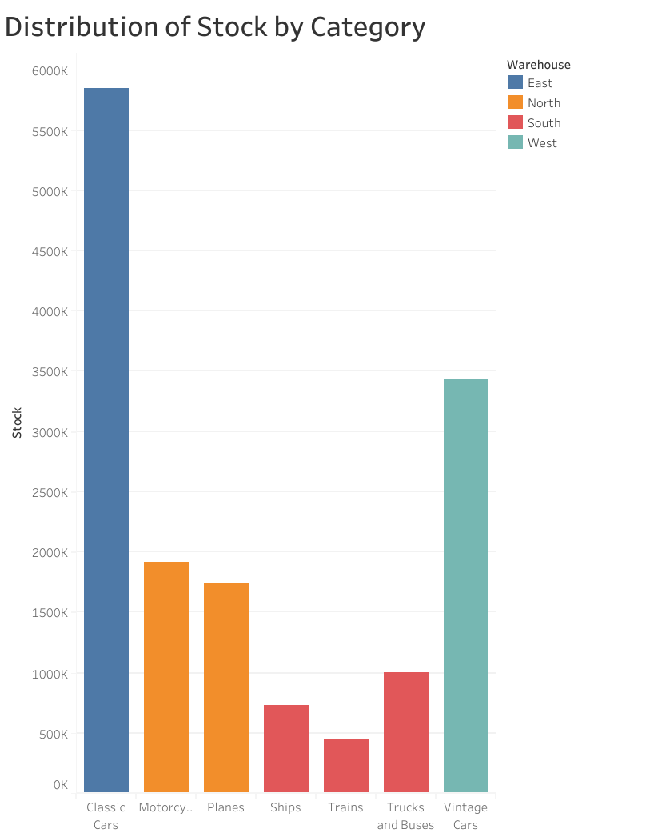
Figure 1
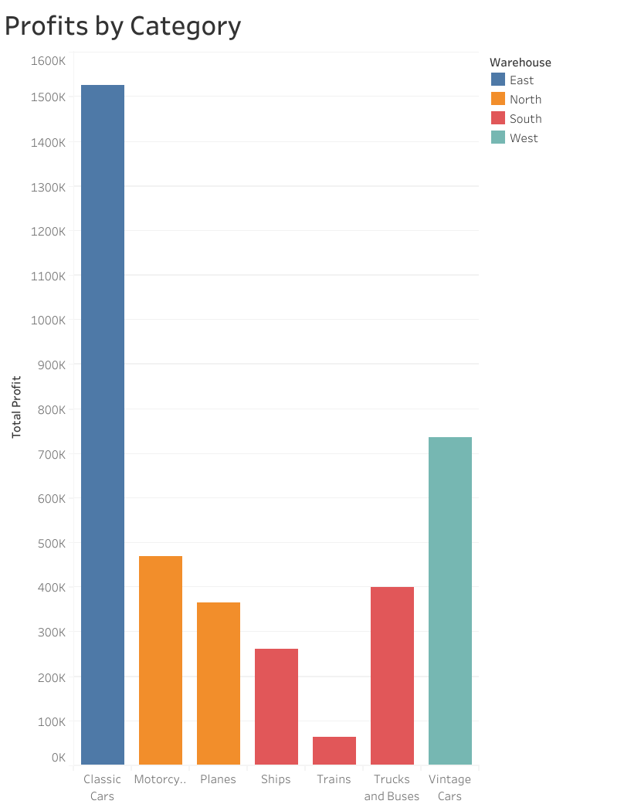
Figure 2
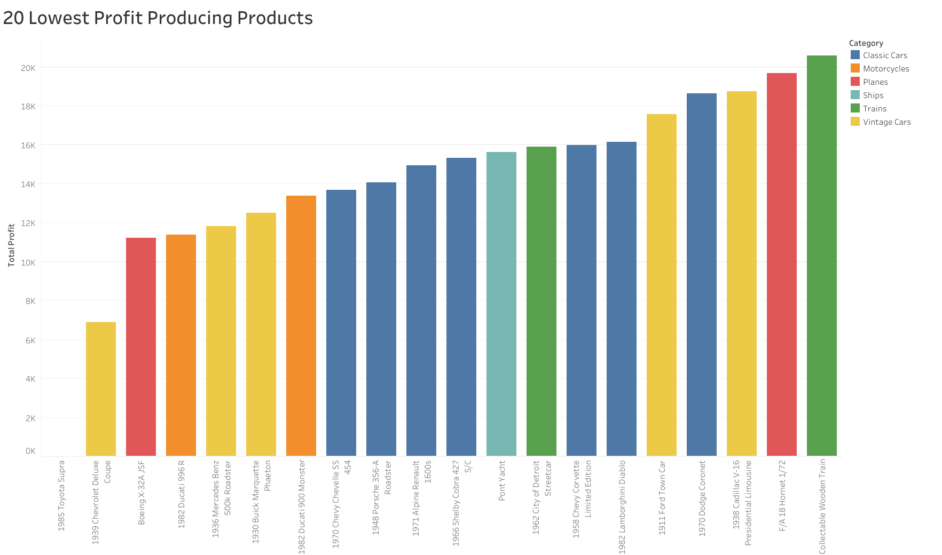Figure 3 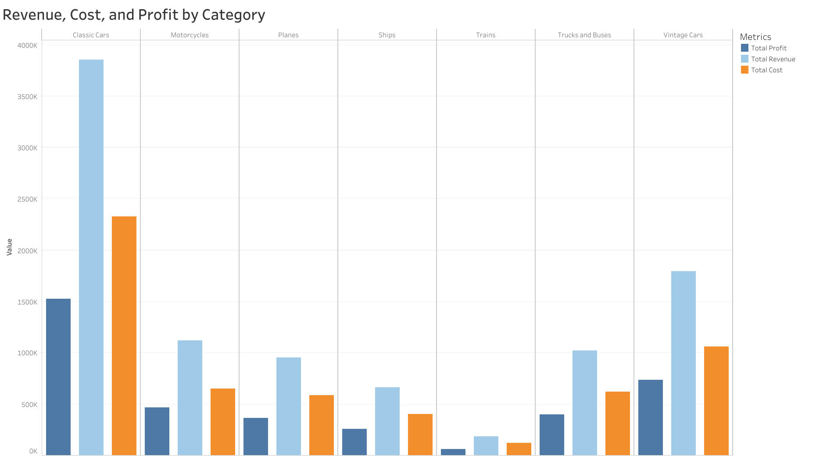
Figure 4

The inventory levels show excessive amounts in all product categories. The analysis of sell-through percentage and inventory turnover rate shows that most products have excessive inventory because their sales performance does not support sustaining those big stock levels. The company achieves its strong absolute revenue and profit numbers by maintaining excessive inventory levels. The Classic Cars and Vintage Cars categories generate the highest profits but their unsold inventory calls for notable capital which makes them an excellent chance to optimize stock levels without jeopardizing customer (See figures 5-8).

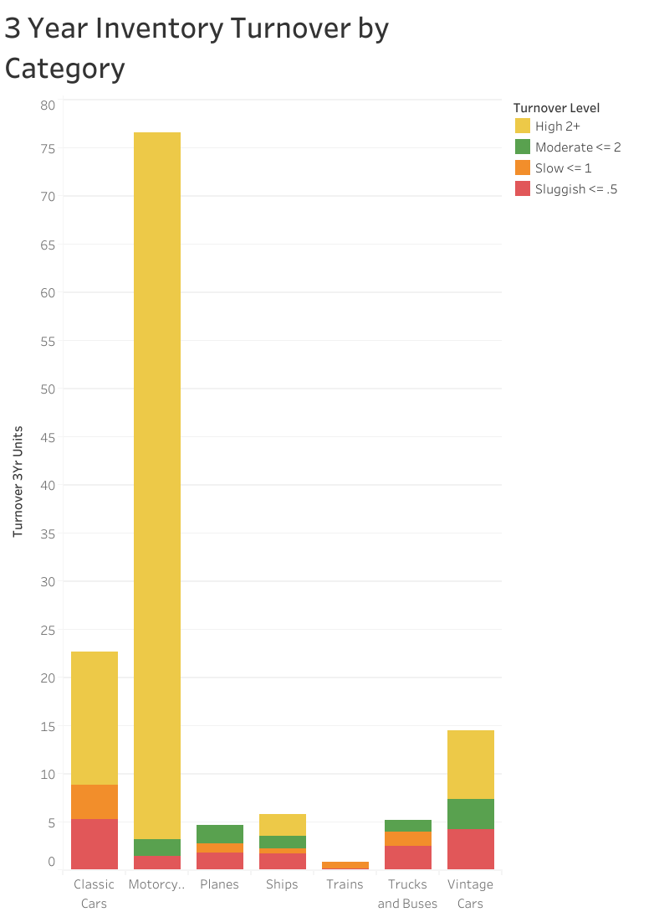
Figure 5

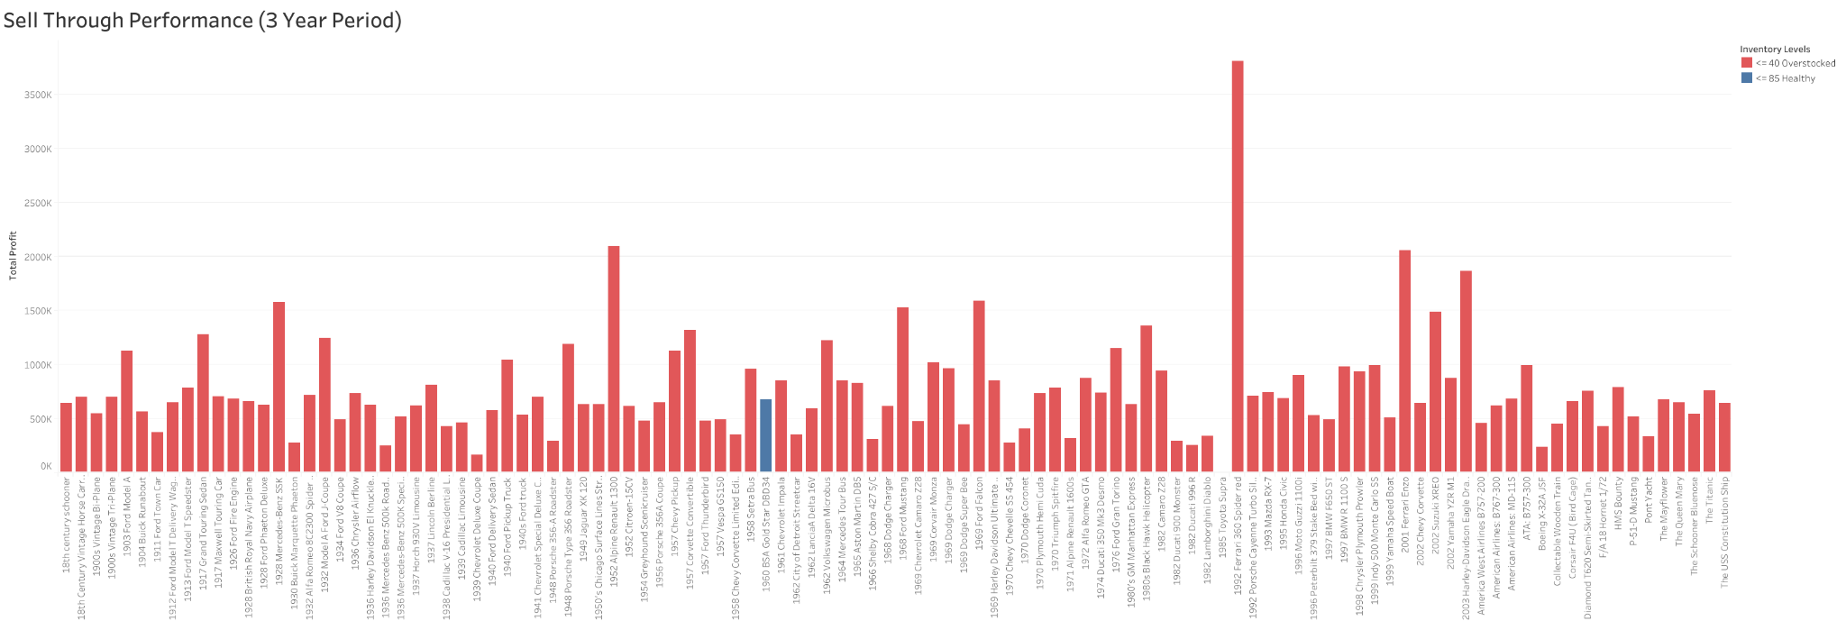
Figure 6

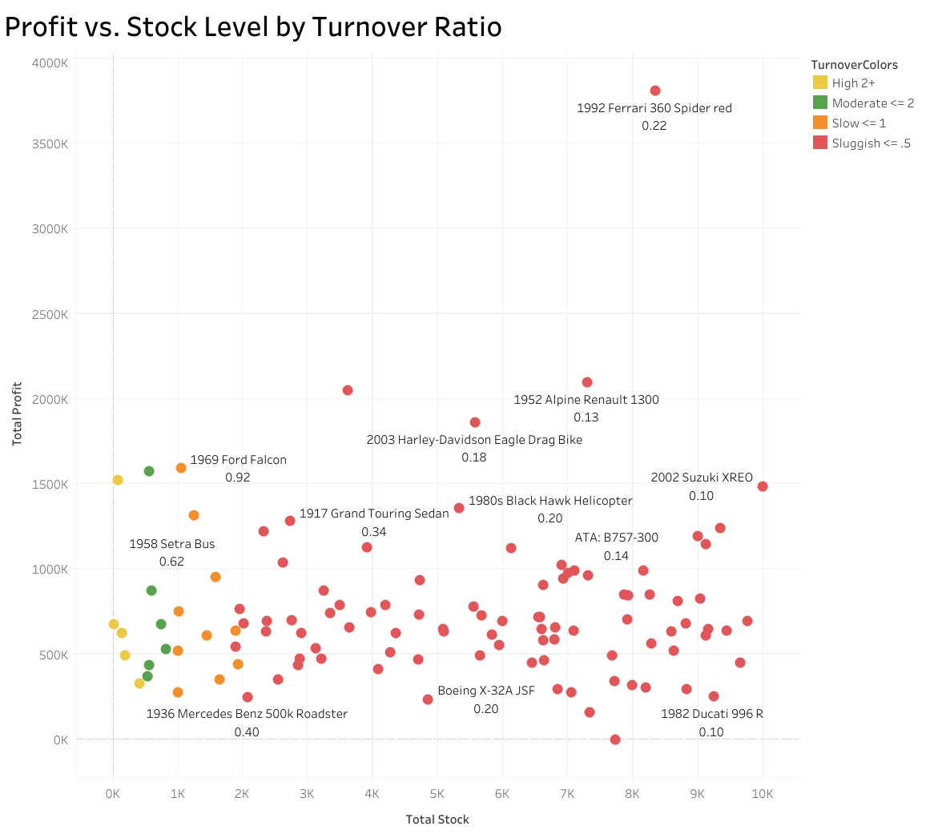
Figure 7

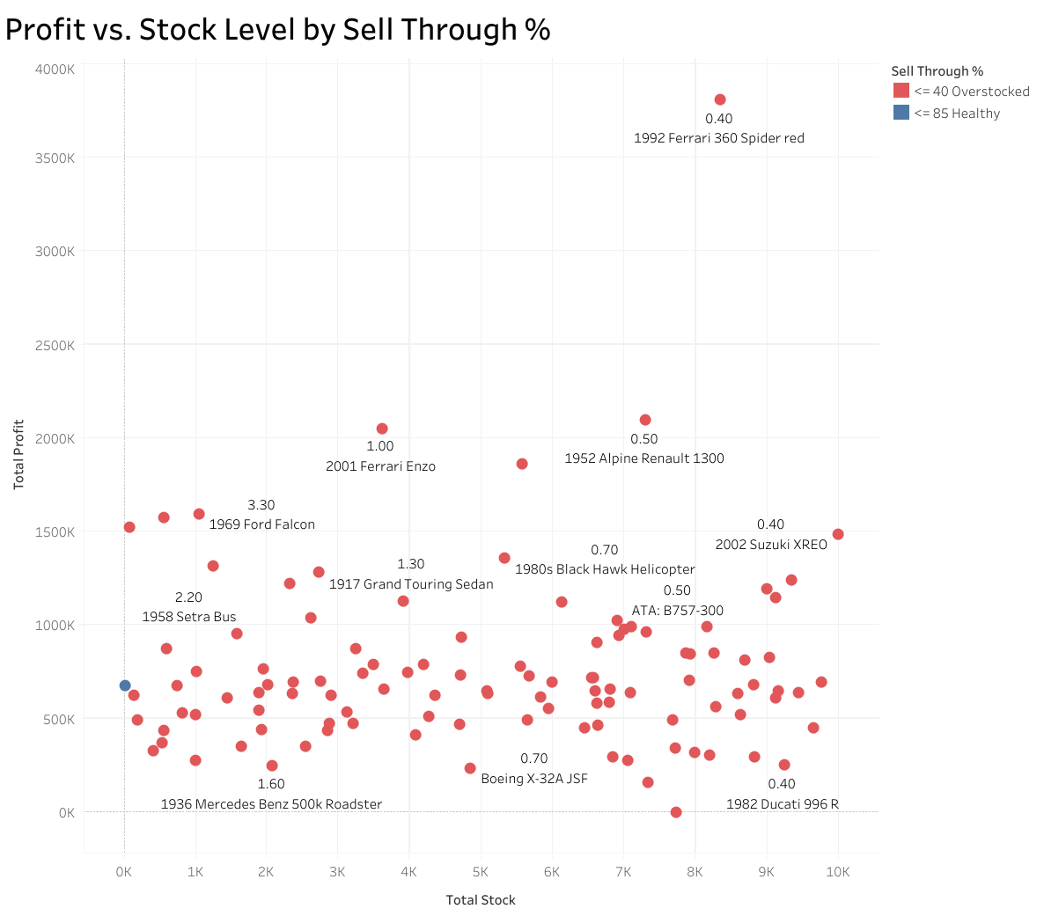
Figure 8

Conclusions and Recommendations
The current inventory levels at Mint Classics exceed necessary amounts because the company holds excessive stock which could be lowered without affecting its ability to meet customer demands. The company needs to stop producing its less successful products because this action will help them maximize their warehouse capacity while achieving better financial results. The Classic Cars product line generates the highest profits but removing the seven worst-performing models from this segment would improve business efficiency.
The present data shows that warehouse closure becomes achievable through planned inventory movement to particular storage areas. The Vintage Cars inventory should move from the West warehouse to the three other facilities which should distribute it based on their available storage space to achieve cost reduction without affecting service quality or product accessibility (See figures 9 and 10).

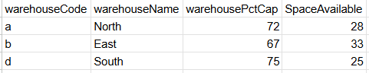
Figure 9

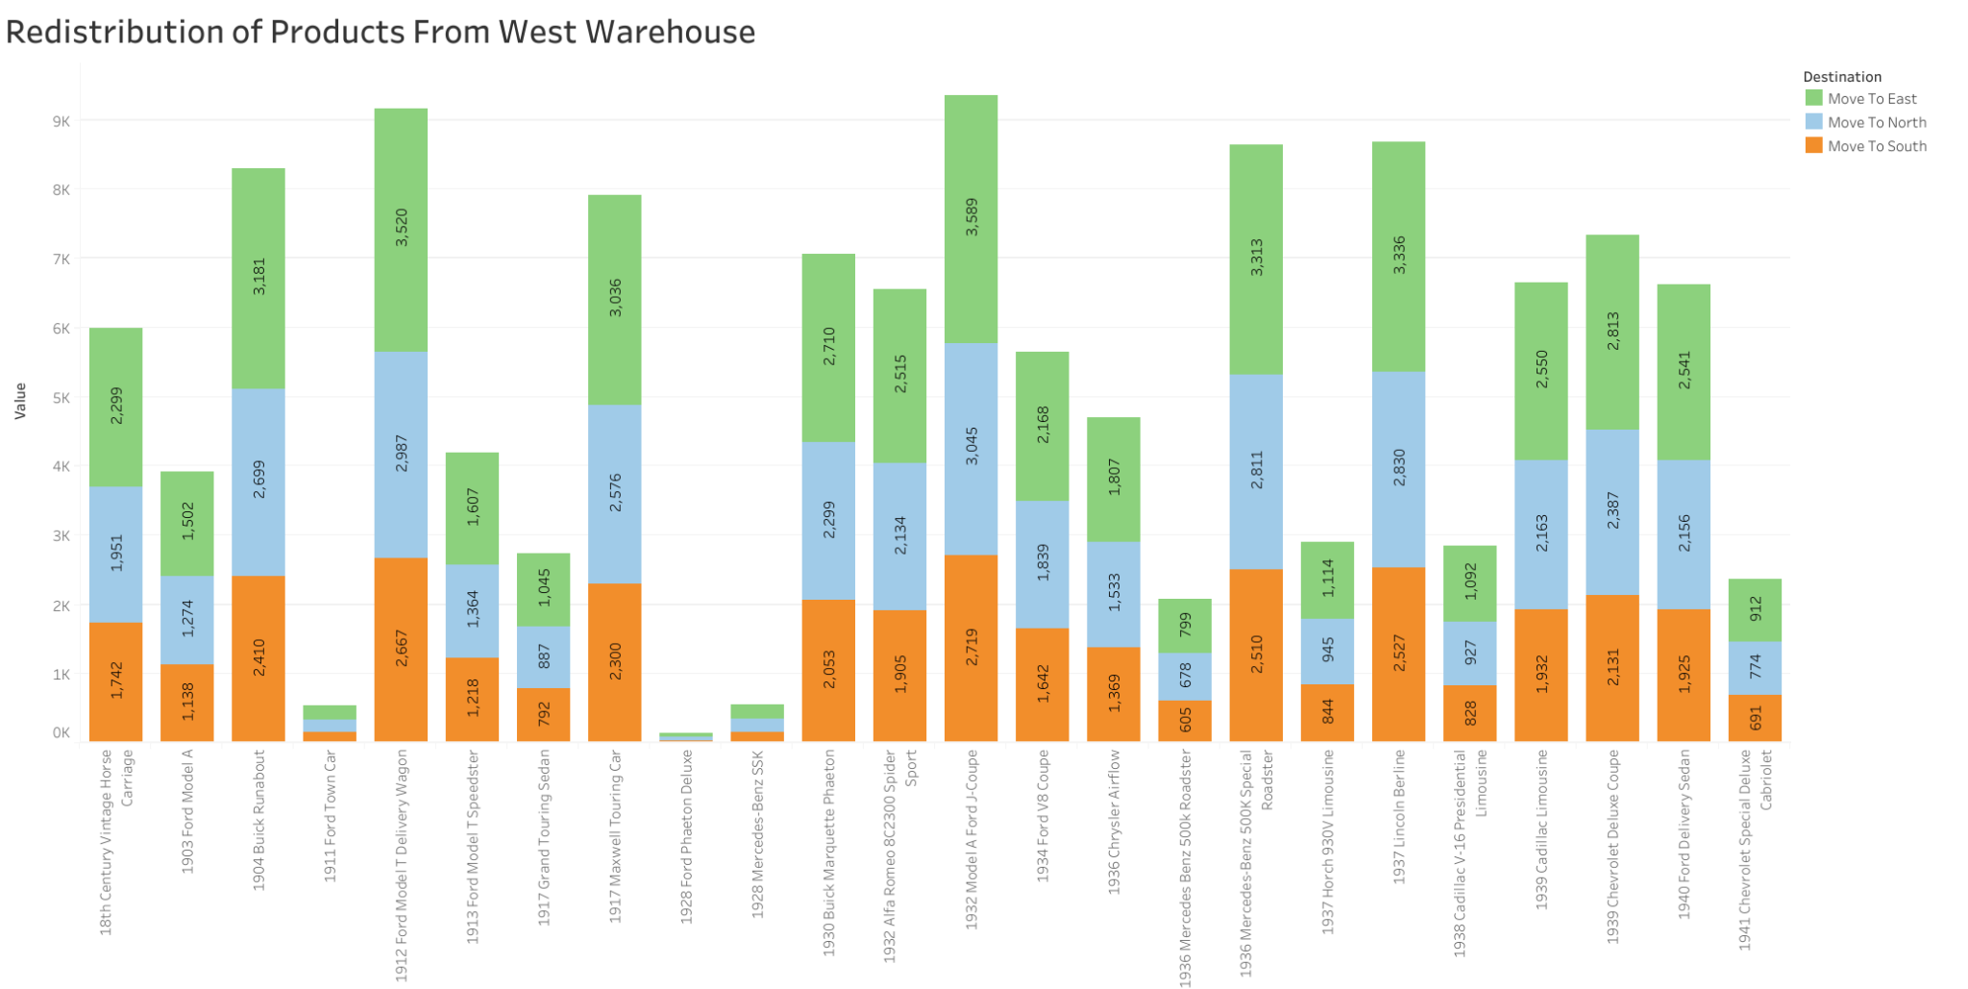
Figure 10

References
27 Inventory Management Terms You must know - Fishbowl. (n.d.). 27 Inventory Management Terms and Definitions You Must Know. https://www.fishbowlinventory.com/blog/27-inventory-management-terms-and-definitions-you-must-know
Boomer, B. (2025, September 26). What is a good inventory turnover ratio? Sortly. https://www.sortly.com/blog/what-is-a-good-inventory-turnover-ratio/#:~:text=An%20inventory%20turnover%20ratio%20between,business%20out%20of%20the%20red.
Funds, O. (2025, September 21). Inventory Turnover Benchmarks by Industry 2025. Onramp Funds. https://www.onrampfunds.com/resources/inventory-turnover-benchmarks-by-industry-2025#:~:text=Definition%20and%20Calculation,Factors%20That%20Affect%20Industry%20Benchmarks
LearnSQL.com Team. (2023, September 5). MySQL Cheat Sheet. LearnSQL.com. https://learnsql.com/blog/mysql-cheat-sheet/
Spiotta, J. (2025, August 14). Understanding Sell-Through rate. SPS Commerce. https://www.spscommerce.com/blog/sell-through-rate/

